**What is Spring Boot**

**Working with Spring**:

Building a spring application is really hard. When we are working with Spring application, we have to care about

1. What Maven archetype we use?
2. Which Maven dependency do we need?
3. How do we set up configuration (XML or Java)?
4. Which server we should use? Tomcat, JBoss, etc. …

And that’s just the basics for getting started. When we started our business application like E-commerce app, Travel app a lot of work will involve with that.

**Problem**:

Tons of configuration in Spring application, like dispatcher servlet, XML, URL mappings, setup component scanning, annotations, view-resolver and so on. For solving this type of problem, we have a easier solution. And the solution is Spring Boot.

**Spring Boot Solution**:

1. Make it easier to get started with Spring development
2. Minimize the amount of manual conﬁguration
   1. Perform auto-conﬁguration based on props ﬁles and JAR class path
3. Help to resolve dependency conﬂicts (Maven or Gradle)
4. Provide an embedded HTTP server so you can get started quickly
   1. Tomcat, Jetty, Undertow, …

**Spring Initializr**:

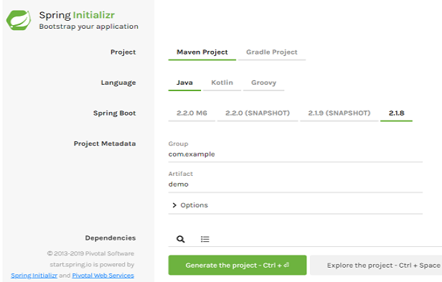

Spring boot provide the "**Spring** **Initializr**". It is a website for

1. Quickly create a starter Spring project.
2. Select our dependencies.
3. Create a Maven / Gradle project.
4. Import the project into our IDE.
   1. Eclipse, IntelliJ IDE, NetBeans etc. …

**Spring Boot Embedded Server**:

1. Spring Boot provide an embedded HTTP server so we can get started quickly.
2. Tomcat, Jetty, Undertow, …
3. No need to install a server separately

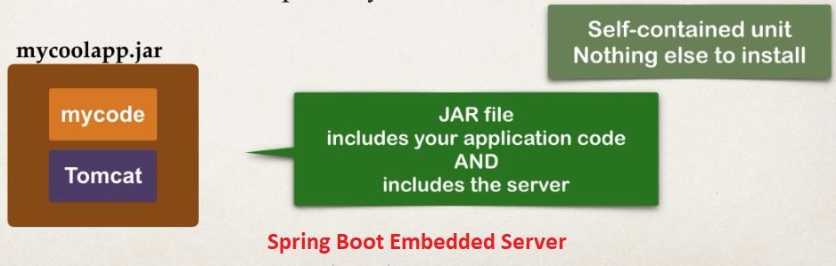

**Running Spring Boot Apps**:

1. Spring Boot apps can be run standalone (includes embedded server)
2. Run the Spring Boot app from the IDE or command-line

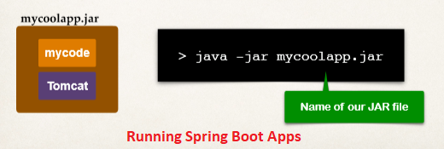

**Deploying Spring Boot Apps**:

1. Spring Boot apps can also be deployed in the traditional way.
2. Deploy WAR ﬁle to an external server:
   1. Tomcat, JBoss, WebSphere etc.

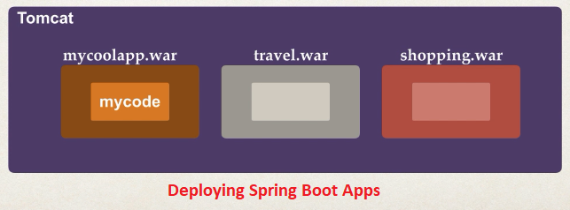

**Some question and answer about Spring Boot**:

1. **Q: Does Spring Boot replace Spring MVC, Spring REST etc. …?**

**Ans**:

No. Instead, Spring Boot actually uses those technologies Spring MVC, Spring REST, Spring Core, Spring AOP etc. Once we do Spring Boot configs then you make use of regular Spring coding

@Component

@Controller

@Autowired

Etc. …

1. **Q: Does Spring Boot run code faster than regular Spring code?**

**Ans**:

No. Behind the scenes, Spring Boot uses same code of Spring Framework. Remember, Spring Boot is about making it easier to get started, minimizing conﬁguration etc.

1. Do we need a special IDE for Spring Boot?

**Ans**:

No. We can use any IDE for Spring Boot apps. The Spring team provides free Spring Tool Suite (STS) [IDE plugins]. Some IDEs provide fancy Spring tooling support. Not a requirement. Feel free to use the IDE that works best for you.

What is Spring Boot